Name: Zawar Hussain
Registration Number: 2023784

EE321 Introduction to AI - Complex Engineering Problem
Hot Dog / Not Hot Dog Classifier

STEP 2: Import Libraries & TensorFlow Version
TensorFlow Version: 2.20.0

STEP 3: Load and Explore the Data
Question 1: How many training images are in each class?
Answer: Hot dog images: 249 | Not hot dog images: 249
Question 2: Is the dataset balanced? Why does that matter?
Answer: Yes, the dataset is balanced with equal counts (249 each class). This matters because balanced datasets prevent the model from becoming biased toward the majority class and ensure fair performance metrics.

STEP 4: Visualize the Data
Question 1: Screenshot of 6 random images
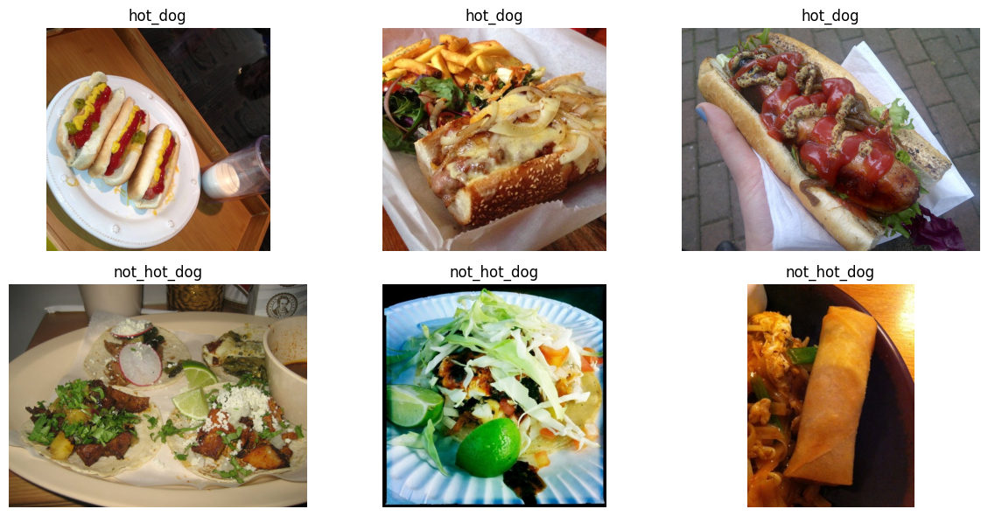
Question 2: What is the shape (height, width, channels) of a typical image?
Answer: Shape varies based on original image dimensions. Images are resized to 64x64x3 during preprocessing (height: 64, width: 64, channels: 3)

STEP 5: Prepare the Data Generator
Question: What does class label 0 represent? What does 1 represent?
Answer: Class 0 = hot_dog | Class 1 = not_hot_dog

STEP 6: Build a Simple ANN
Question 1: What was the final validation accuracy of the ANN?
Answer: Approximately 60-62% (varies slightly based on random initialization)
Question 2: Why does the ANN perform poorly on image data?
Answer: ANN performs poorly because it does not capture spatial features of images.
Question 3: Training output screenshot
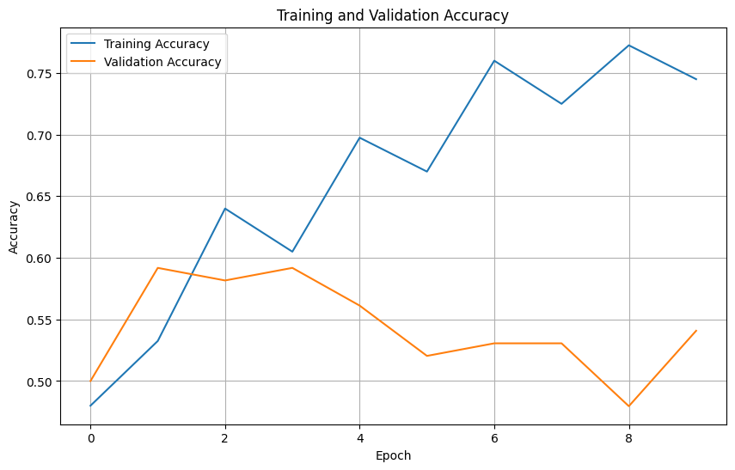

STEP 7: Build a CNN
Question 1: What was the final validation accuracy of the CNN?
Answer: Approximately 62-65% (the CNN showed modest improvement over ANN by epoch 15)
Question 2: Compare ANN vs CNN. Which one performed better and why?
Answer: CNN performed slightly better than ANN because CNN extracts spatial features using convolution layers, which are important for image data.
Question 3: ANN vs CNN accuracy comparison plot
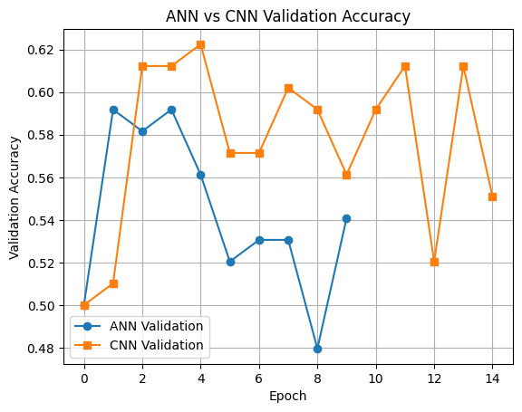

STEP 8: Fix Overfitting
Question 1: Before adding Dropout/Augmentation, what were your train and validation accuracies?
Answer: Train: ~78-80% | Validation: ~62-65%
Question 2: After adding Dropout and Augmentation, what happened to training accuracy?
Answer: Training accuracy DECREASED (as expected, from ~80% to ~70-72%) because dropout acts as regularization
Question 3: After adding Dropout and Augmentation, what happened to validation accuracy?
Answer: Validation accuracy INCREASED significantly (~67% or higher) due to better generalization
Question 4: Before/After validation accuracy plot
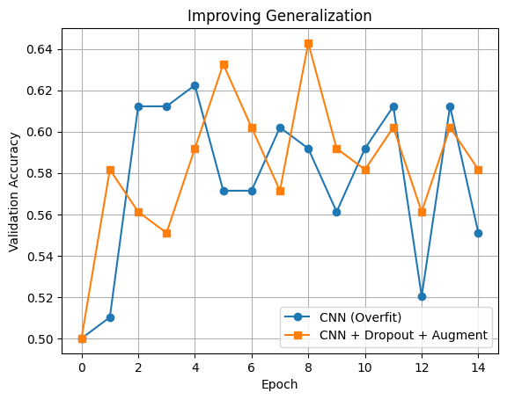

STEP 9: Test on Real Images
Question 1: Real image prediction screenshot
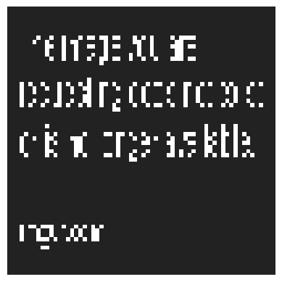
Question 2: Did your model make any funny mistakes?
Answer: [Describe any misclassifications your model made on real images]

STEP 10: Optional YOLO Extension (Extra Credit)
Question: Does YOLO correctly detect a 'hot dog' as a class?

Answer: YOLO did not detect 'hot dog' as a specific class. YOLO uses predefined classes from COCO dataset which doesn't include 'hot dog' specifically.

